Create a SubReport

- Create a sub-report bean

public class RptSampleBean extends RptBaseBean {
private String attrib1 = null;
private String attrib2 = null;

public RptSampleBean() {
}
...
}

- Add a set of factory methods

public class RptBeanFactory {
public static RptSampleBean createRptSampleBean()
public static RptSampleBean[] createRptSampleBeanList()
public static JRBeanArrayDataSource createRptSampleDatasource()
public static JRBeanArrayDataSource createRptDatasource(…)
}

- Define a datasource connection

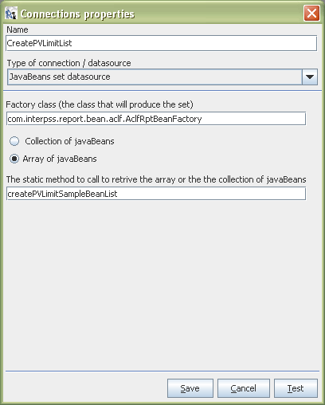

- Define report query

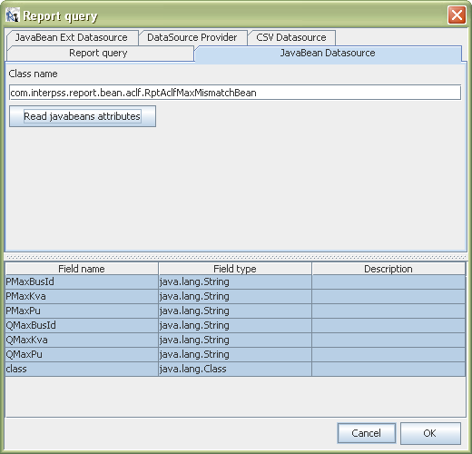

- Bind the Field to the report text
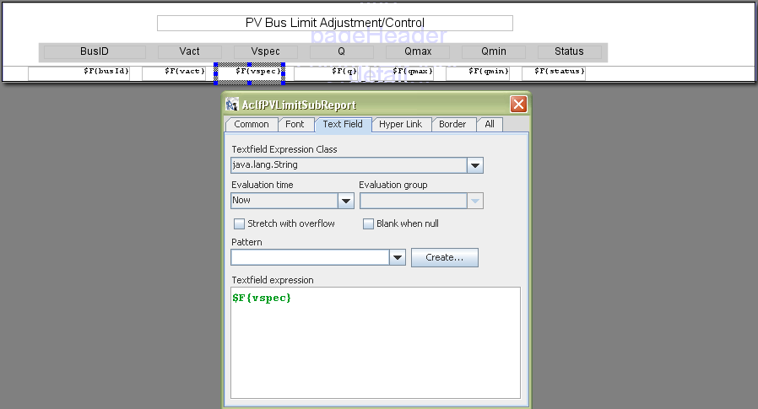
- Compile and run the subreport

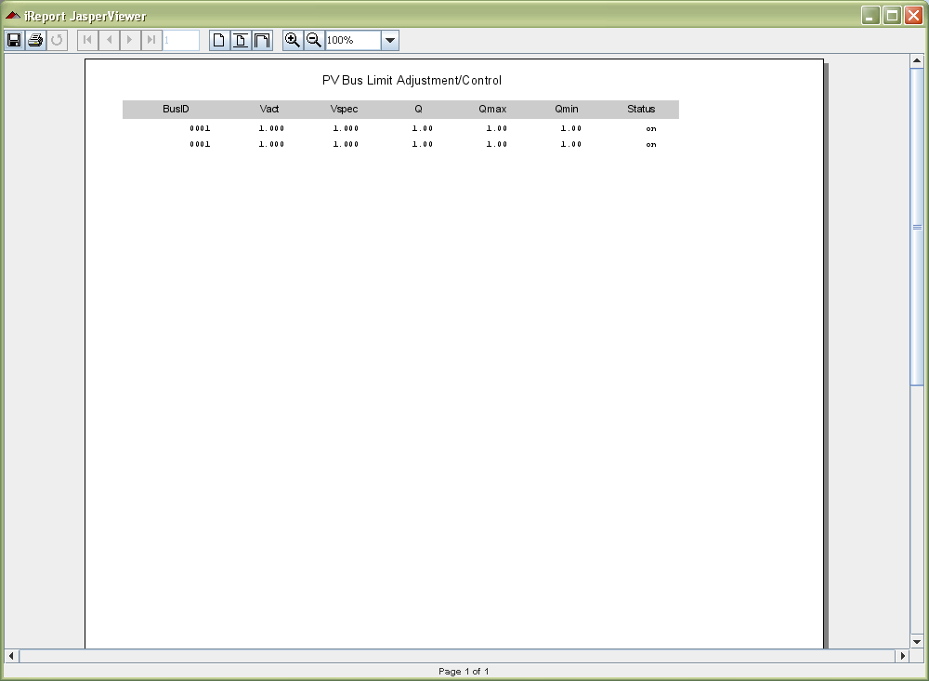
Integrate a SubReport into the Master Report

- Add *JBeansource and *SubreportFilename parameters

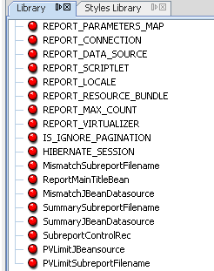

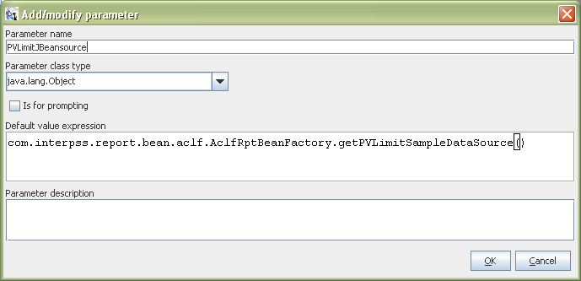

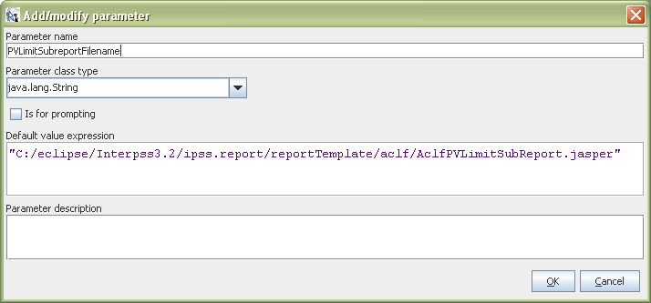

- Add an attribute to the SubreportControlRec

public class AclfRptSubrptControlRec {
private boolean pvLimitSubreport = true;
}

- Config Subreport

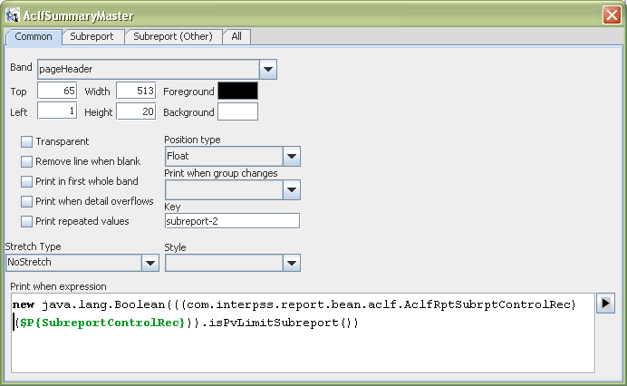

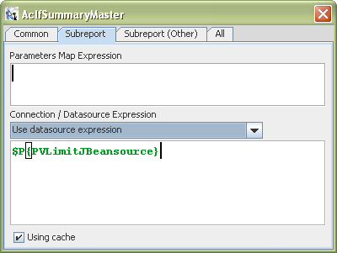

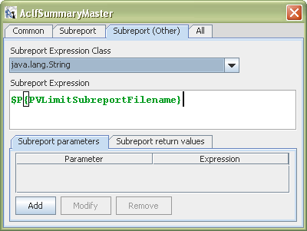

- A subreport could be added into the page Header section or Summary section

